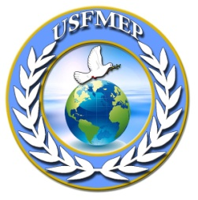
US Federation for Peacekeeping and Sustainable Development
Connecting Continents for Peace
“Special Consultative Status with the ECOSOC and DPI of the United Nations” Non-Profit Organization; 501(C)(3); Tax ID (#26-0083557)

USFMEP Press Release

USFMEP Education Program for Handong Global University Students of the Republic of South Korea; 21st January, 2016
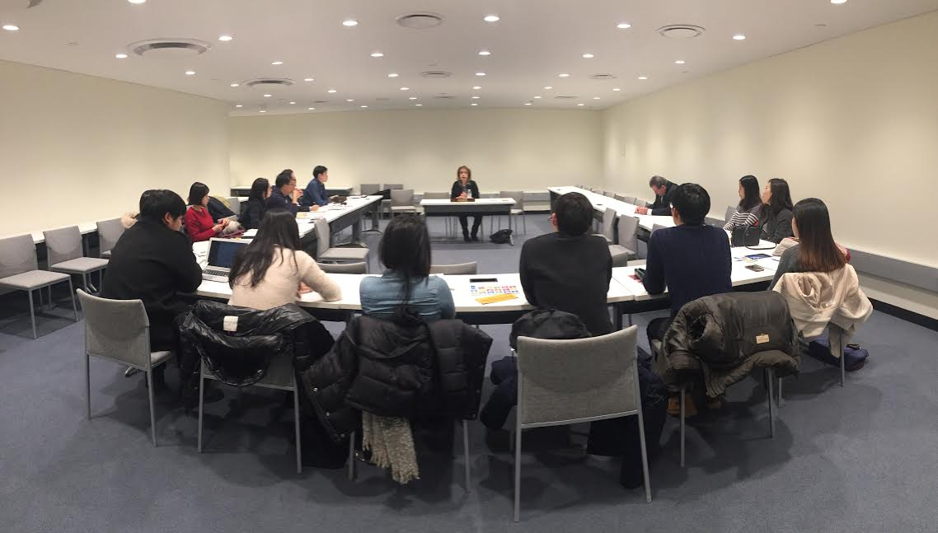
USFMEP is proud to highlight its one-day educative seminar for a group of brilliant students from Handong Global University, the Republic of South Korea. This select group of students study international politics, and partook in a trip to New York as part of the Global Training and Research (GTW) program run annually by the university. The panel was held in Conference Room F at the UN Headquarters in New York City.
USFMEP President Mrs. Sally Kader led the seminar, creating an intimate environment where students could be able to ask questions, inquire, and discuss on the topic of the current Syrian refugee crisis, as well as what the United Nations High Commissioner for Refugees (UNHCR) has done to tackle the problem.
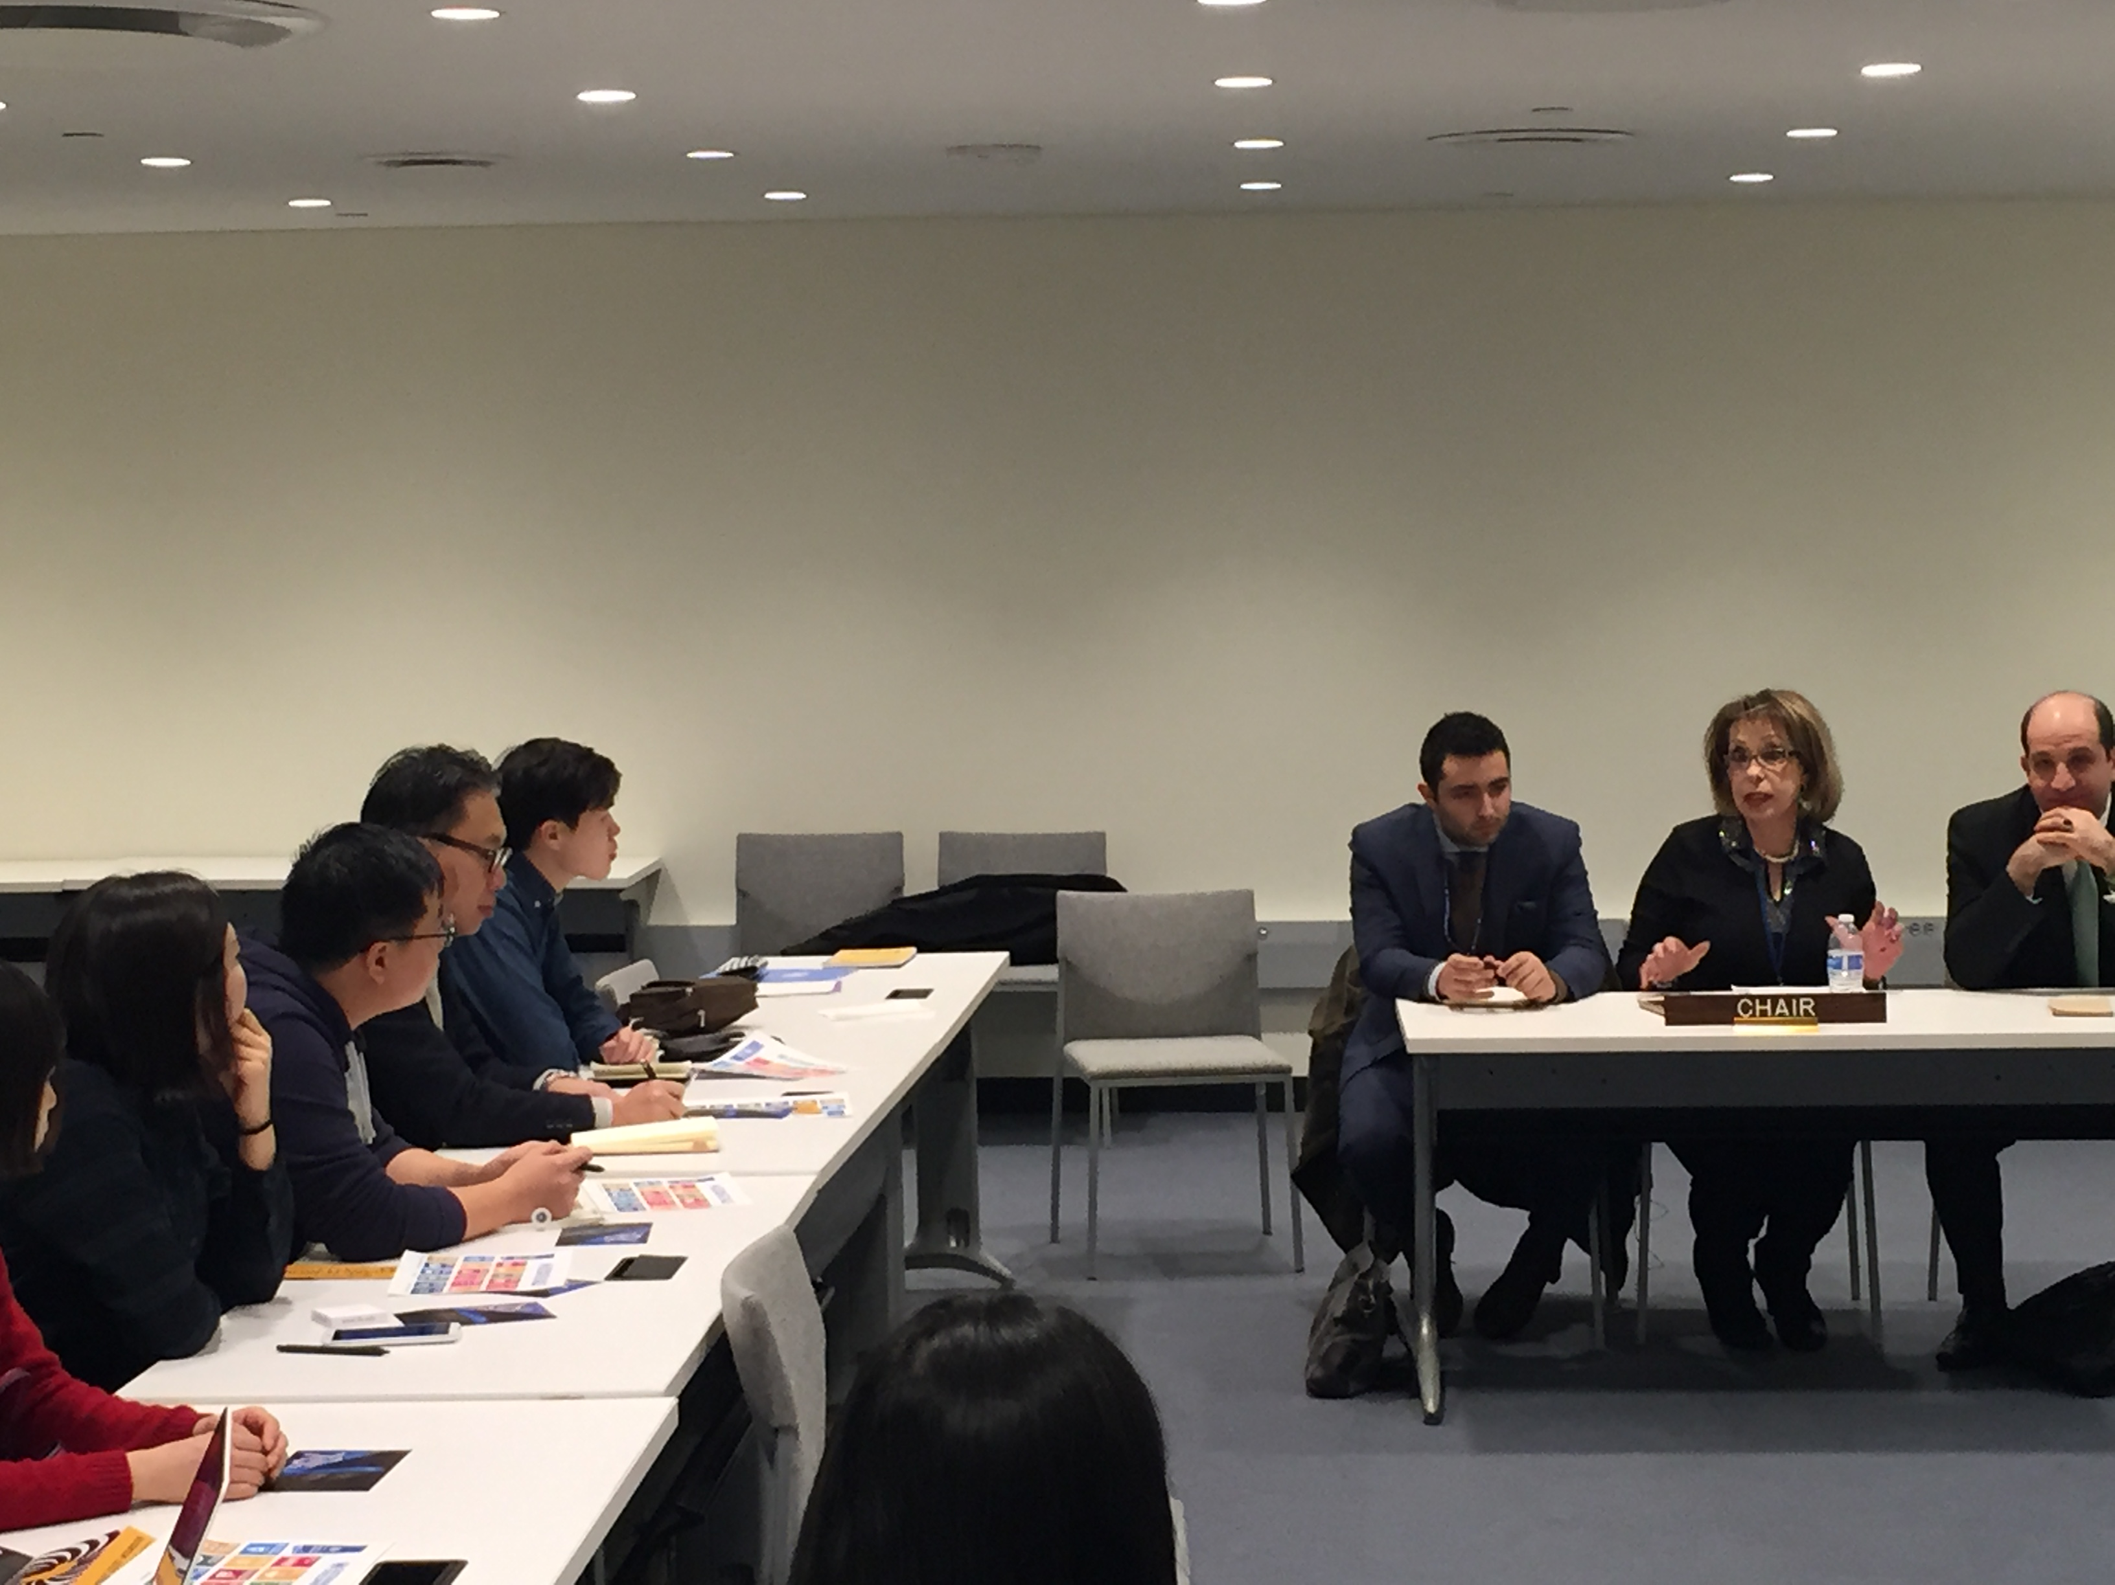
President Kader and CEO Ralph Kader greeted the students with a warm welcome, and as President Kader states: "It is these kind of opportunities that we cannot take for granted, that is, having an interested and engaged group of young people wishing to learn about issues of such global importance, and it is our duty as not only an organization, but as adults, to equip the youth with the proper tools for them to be able to tackle situations like these effectively".
Central to USFMEP’s mission, protecting human rights and promoting peace are critical in solving this particular issue. Having officially visited the Syrian refugee camp Zataari in Jordan and made her own generous donations, President Kader, using her own experience offered students fresh and activist insights into this political issue of global imperative urgency. As strongly held by USFMEP, its mission is to promote international peace, security and justice, and it is no longer acceptable to neglect in the slightest situations like the refugee crisis. Thus, through programs and panels such as this one, it is the belief of USFMEP that an imprint can be left in the hearts of young people to feel inspired to make a change in pursuit of peace.
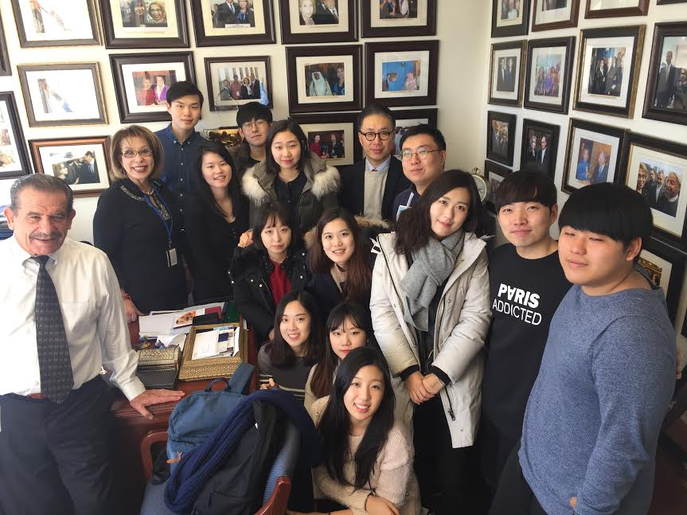
USFMEP spares no effort in educating the youth, which is why President Kader provided the group of professor and students with this unique lesson looking at the recent issue. USFMEP looks forward to keeping the liaison and collaboration with the GTR program at Handong Global University, and to continue taking advantage of such a unique opportunity to educate, inspire, and instigate enthusiasm in the minds of the youth.

